**Territorial Acquisition**

**Task:** To create a 2-4 player game based around historical territory acquisition. This game is to be designed via resources on the internet. Rules must include a winning condition for one clear winner, whether it be through conquering all territory or the most

**Diary Entry #2 By Zakaria Ahmed**

Team- Zakaria Ahmed, Cory Arnett O’Brien, Giancarlo Trinidad

**1.0 Game Premises**

All students were allocated into teams and given a briefing on a game that would later be made and presented. It was to create a game based on historical territorial acquisition; this could be shown via the gameplay as well as the inspiration of idea from historical events.

**1.1 Materials**

These materials were to be entirely online based due to current circumstances in society. Here are what was used and its purpose:

Construct 3 – An online based programming tool that was used to create the game, its simplicity and ease of access is what allowed the game to be created

Presentation Software – Screenshots and annotation of the game’s development was saved onto a presentation to be later used to show to the class and showcase.

**1.2 Rules and Mechanics**

The mechanics are that players can move around a board full of tiles and landing on a tile would change that tile to the player’s colour, indicating that they have claimed it. Other players would have to compete in a “**battle**” to claim conquered tiles (battle refers to a dice roll both players would make, rolling a die higher than the other player would mean that the player would’ve won the fight and taken over the tile)

For the **battle** mechanic, adjacent tiles also effect how many dice are rolled for each player, for every tile of your colour touching the tile that is to be battled for, you would get an additional die to roll. **Note that the battle is determined by the highest die number and not the combined dice total**

To start, all players will roll a die to determine the order that each player would go in- higher number being played first and a tie in number would result in the younger player going first. Each player can move up to 3 tiles and every tile they pass can be conquered with ease. Every enemy tile you pass is battled for and if you lose your turn ends and the next player moves. The game ends after roughly 11 turns in which the player with the most conquered tiles win.

**1.3 How the game is played**

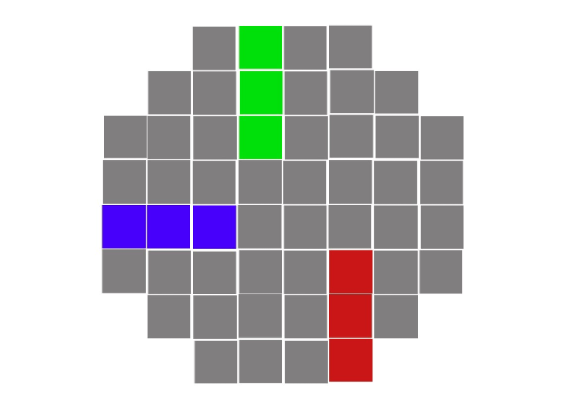**Figure 1**:” A” represents an individual unmarked tile that fills the board, these tiles can be moved upon and change colour as you pass over them. For example, “B” shows the blue player moving over tiles and marking them as their own territory via a colour change.

A

A

B

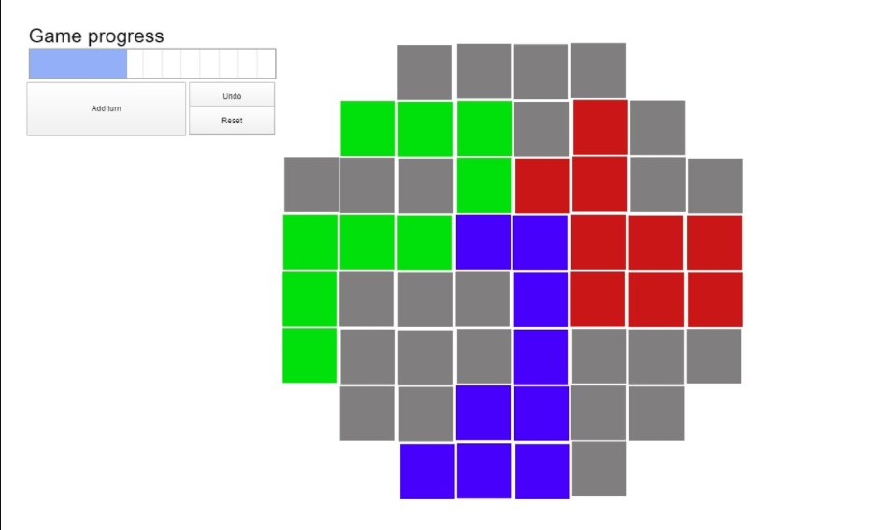**Figure 2**: A later iteration of the game. “A” shows the game progress bar added- a way to display the round counter and would indicate how close a game is to finish. Here you can also see a more developed gameplay as players are conquering each other’s territory

**1.4 Play Testing**

Internal play testing was done throughout game development to determine any problems that needed to be solved before presentation time. One problem that occurred was that there was no digital display of the round counter in early developments. Figure 1 shows no display which meant that keeping track of rounds were difficult, a solution was to create a counter to remember what round you were on

**1.5 Teamwork/ Reflection**

Referring to 1.4, we have solved a problem together by decomposing our gameplay into simple tasks, playing the game, reviewing our opinions on it, fixing our concerns with the game. By doing this, we all concluded that not having a round tracker would complicate the player as they need to remember the round they played, we reflected on this and decided to add one in the end as it would make the game flow smoother since everyone could pay attention to the game.